**Decision Tree Regression**

* Decision Tree is a Supervised learning technique that can be used for both classification and Regression problems, but mostly it is preferred for solving Classification problems. It is a tree-structured classifier, where internal nodes represent the features of a dataset, branches represent the decision rules and each leaf node represents the outcome.
* In a Decision tree, there are two nodes, which are the Decision Node and Leaf Node. Decision nodes are used to make any decision and have multiple branches, whereas Leaf nodes are the output of those decisions and do not contain any further branches.
* The decisions or the test are performed on the basis of features of the given dataset.
* It is a graphical representation for getting all the possible solutions to a problem/decision based on given conditions.
* It is called a decision tree because, similar to a tree, it starts with the root node, which expands on further branches and constructs a tree-like structure.
* In order to build a tree, we use the CART algorithm, which stands for Classification and Regression Tree algorithm.
* Here we are finding the 3rd axis y value.

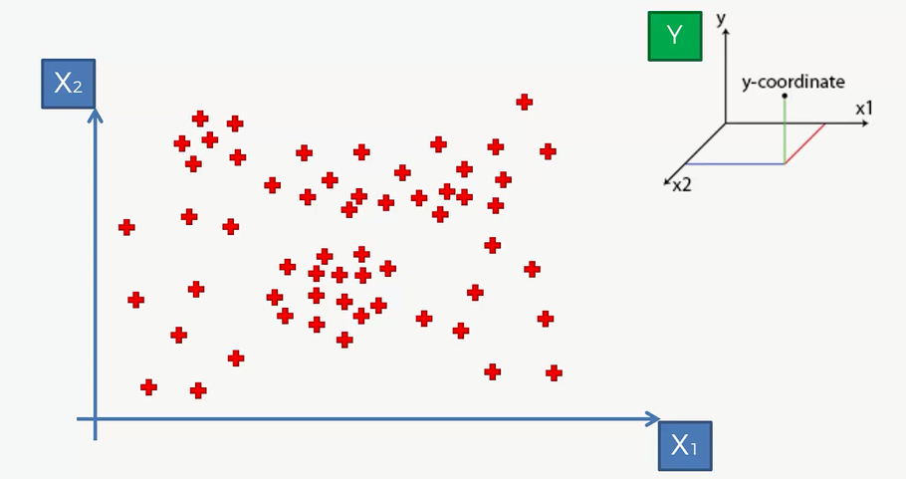

* The next will be splitting into number of leafs, where it should not be less than 5%.

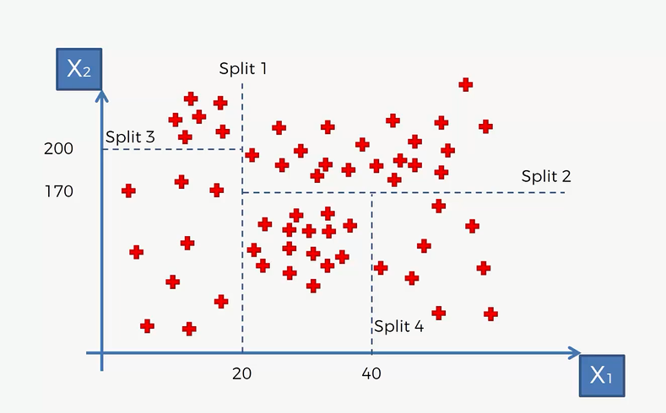

* Here it shows all information of split leafs with its values and yes/no status.

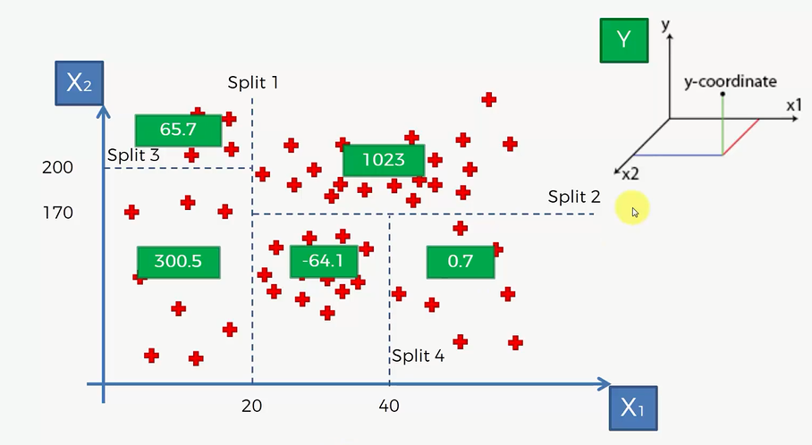

* Hierarchical structure of decision tree

